CMPE 172 Section 2

First Assignment Report

Team Name: GreenFace

Team Members: Viet Van Nguyen, Hoa Nguyen, Minh Ngo

Github Link: https://github.com/MrJc010/HW1_CMPE172.git

**Step 1: Download Ansible on target machines**

(On Ubuntu 18.4)

sudo apt-get update

sudo apt-get install software-properties-common

sudo apt-add-repository ppa:ansible/ansible

sudo apt-get update

sudo apt-get install ansible

A screenshot of a cell phone

Description generated with very high confidence

**Step 2: Set up SSH, server and hosts**

Set up SSH and RSA key between all of the involved machines.

Modify the host files in the server machine (etc/ansible/hosts)

Generate keys: ssh-keygen -t -rsa

Copy public key to the IP address of the server machine

ssh-copy-id -i/home/james/-ssh/id-rsa2.pub 10.0.0.152

(james is the target machine, 10.0.0.152 is IP address of the machine we used in our assignment)

On the client machine, generate key

ssh-keygen

Copy id from client to server machine

scp id_rsa.pub 10.0.0.152 :/home/james

Now, we use ssh to connect to our server

ssh [james@10.0.0.152](mailto:james@10.0.0.152)

Copy public key from a preferred folder to .ssh authorized key

cat id_rsa.pub >> ~/.ssh/authorized_keys

Modify the config file

sudo vi /etc/ssh/sshd_config

Modify as below:

Modify RSAauthentication to yes

Publickey Authentication to yes

ChallengenResponseAuthentication: no

PasswordAuthentication: no

usePAM: no

Then save the file

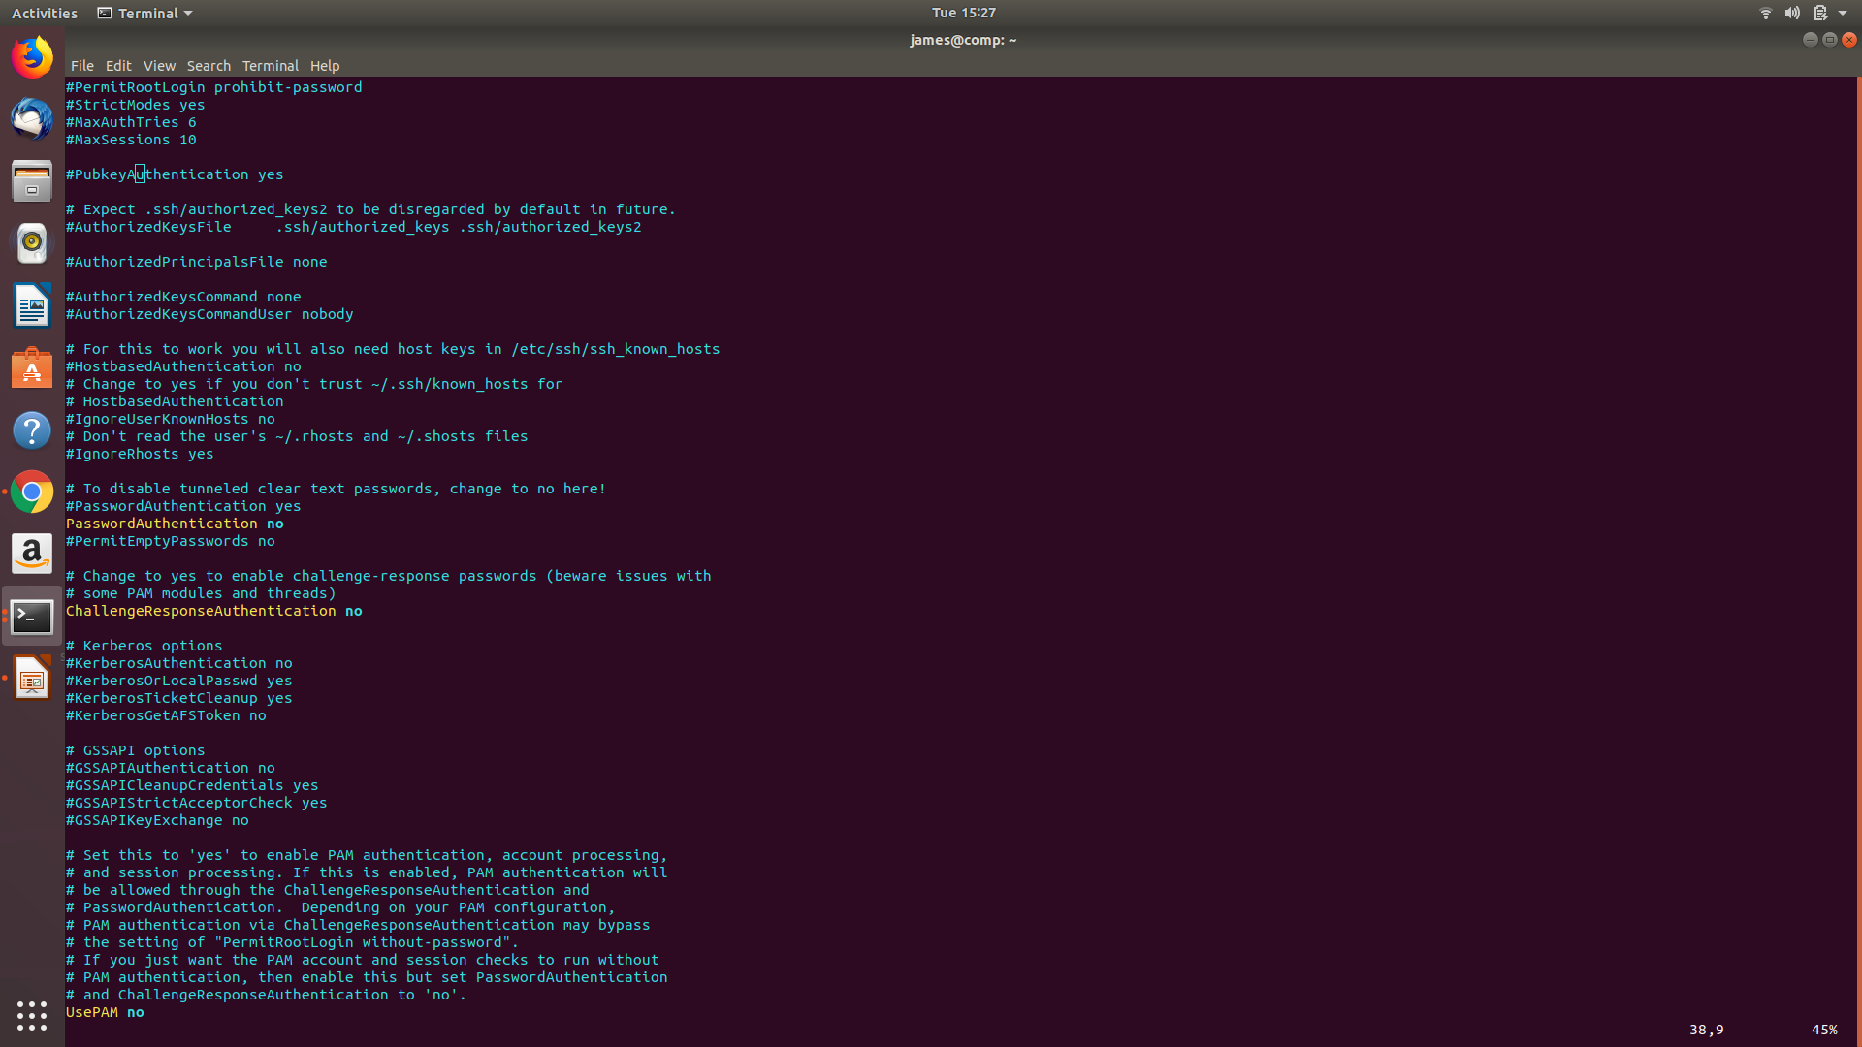

Reload ssh file

sudo/etc/init.d/ssh reload

Change the file ownership

sudo chmod 700 .ssh

Change authorized_keys to 600 permission

cd .ssh

sudo chmod 600 authorized_keys

After all of the above steps, type exit and start connecting.

ssh [james@10.0.0.152](mailto:james@10.0.0.152)

This time, we can connect to all hosts (set in the host file earlier) without any password required.

**Step 3: Creating the Playbook for deploying webserver and un-deploying it**

Create index.html with the <h1>Hello World<h1> tag. Put the file inside the root directory for the corresponding web server. (~var/www/html/index.html)

Create 3 playbooks: the first one to install Apache webserver, the second one is to (deploy) activate the Apache webserver, the last one is to un-deploy the resources.

This is our desire outcome:

When we access to the webserver over port 80, it will render the index.html page

To run Ansible Playbook:

ansible-playbook install_apache.yml

Next, we run second playbook to activate web server

ansible-playbook deploy_website.yml

After that, we can access to the default gateway of the web server over port 80, this is what we get:

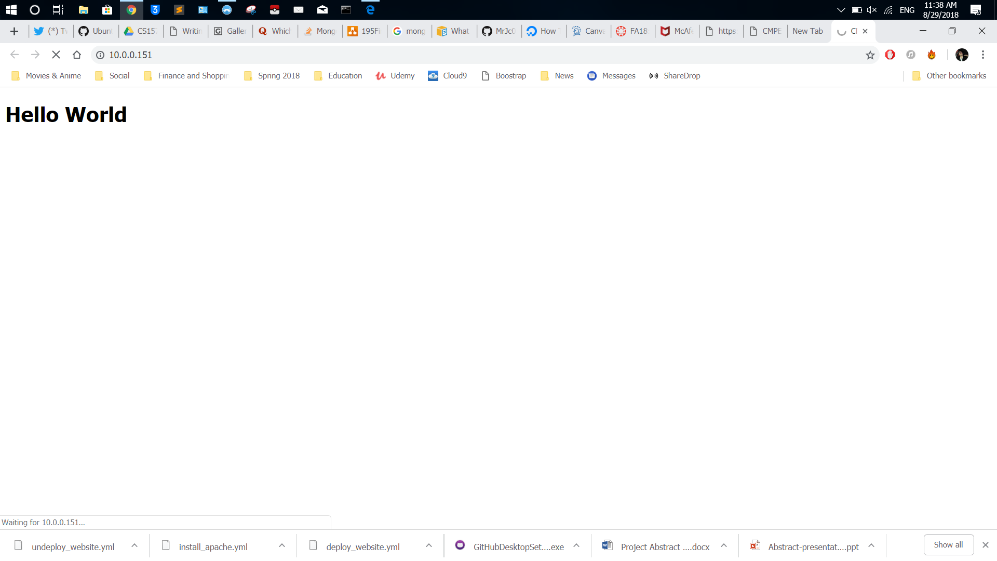

To un-deploy resources, we run undeploy_website.yml (to uninstall apache)

ansible-playbook undeploy_website.yml

After un-deployment, the webserver is down. We can no longer access the Hello World.html page over default gateway of Apache web server.

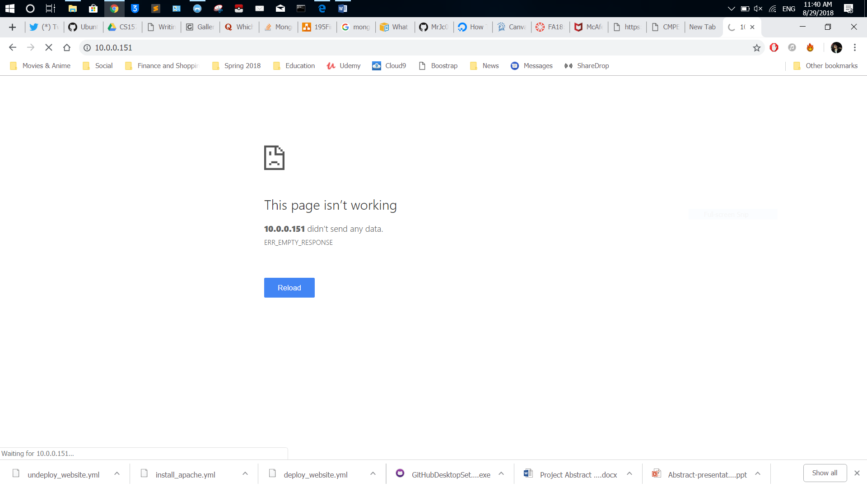

**Github Link: https://github.com/MrJc010/HW1_CMPE172.git**